**1. Download and install**

Download docker：

Officer website：<https://docs.docker.com/install/linux/docker-ce/ubuntu/#set-up-the-repository>

Open the terminal and enter the following commands in order to download and install docker

1. sudo apt-get update

2. sudo apt-get install apt-transport-https ca-certificates curl software-properties-common

3.curl -fsSL <https://download.docker.com/linux/ubuntu/gpg>

4.sudo apt-key add -

5.sudo add-apt-repository “deb [arch=amd64] <https://download.docker.com/linux/ubuntu> $(lsb_release -cs) stable”

6.sudo apt-get update （If this step can not run smoothly run several times, if not enough input “sudo apt-get clean” After running run “sudo apt-get update”）

7.sudo apt-get install docker-ce

8.apt-cache madison docker-ce (This step looks at the docker version)

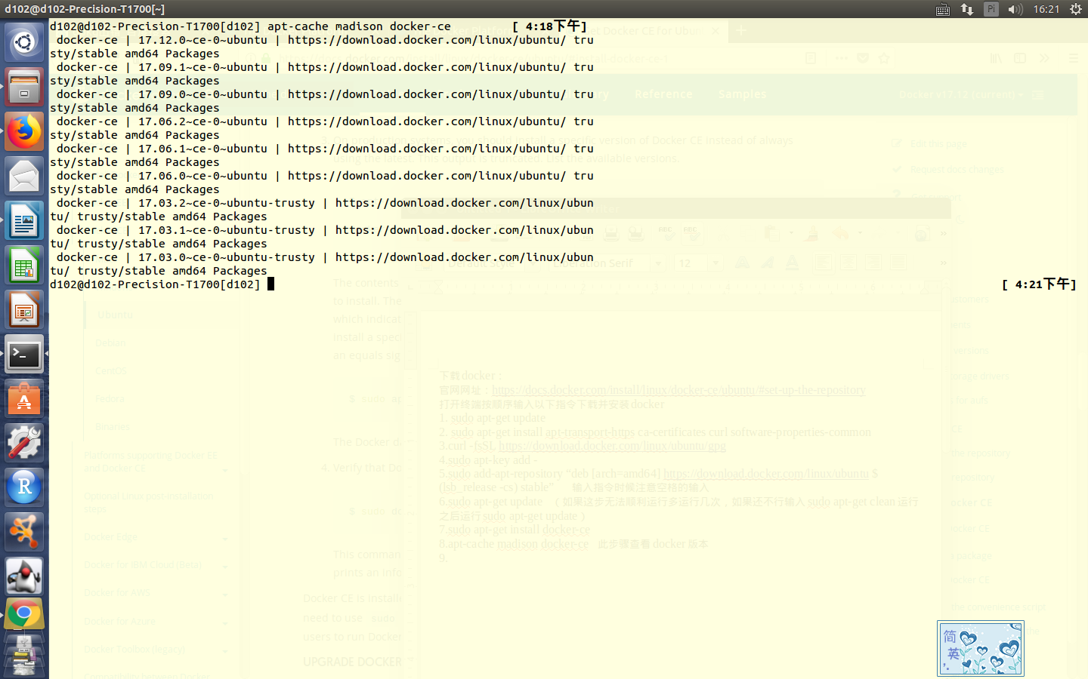

9.sudo apt-get install docker-ce=<VERSION>

<VERSION> Replace the eighth step which you want to install the version

example：sudo apt-get install docker-ce=17.12.0~ce-0~ubuntu

10.sudo docker run hello-world

This step is used to test if docker was successfully installed.

**2.How to use elsa docker image**

Open the terminal and enter the following commands

1. sudo docker pull panhongfei/elsa:1.0
2. sudo docker run -it panhongfei/elsa:1.0
3. cd charade-elsa-7bed46b84456
4. cd test/
5. sh test.sh

How to mount to local file:

sudo docker run -it -v `pwd`:/var/data/ test:1.0

For example:

sudo docker run -it -v /media/d102/disk/panhongfei/charade-elsa-7bed46b84456/test:/install_soft panhongfei/elsa:1.0